Combating Early Investing Barriers Using Machine Learning Among Kenyan University Students

AUTHOR: ELKANAH MOGAKA OMARI
SCT221-0260/2020

SUPERVISOR: MR. JOMO NJENGA

AFFILIATION
A research proposal submitted to the Department of Information Technology in the School of College of Pure and Applied Sciences in partial fulfillment of the requirements for the award of the degree of Bachelor of Science in Information Technology, Jomo Kenyatta University of Agriculture and Technology.
YEAR: 2025

DECLARATION

This proposal/research project is my original work and has not been presented for a
degree in any other University

…………………………………………………………..
Signature
…………………………………..……………………….

Date: 2025/AUGUST

This proposal/research project has been submitted for examination with my approval
as University Supervisor
……………………………………………………………
Signature
……………………………………………………………..
Abstract
Early engagement with financial markets is crucial for long-term wealth creation, yet Kenyan university students face significant obstacles to investing. These include limited financial literacy, lack of accessible educational resources, complex platform interfaces, and behavioral biases such as fear of loss and short-term thinking. This project aims to address these challenges by developing a machine learning–driven financial literacy platform tailored to the needs of university students.
The proposed solution integrates educational modules, portfolio tracking, and intelligent feedback mechanisms to guide users through their investing journey. Machine learning will be employed to personalize content delivery, assess user risk profiles, and provide behavioral nudges that promote consistent and informed investing.
The project will follow an Agile development methodology to allow iterative refinement based on user feedback and data insights. Key components will include user-centered design, behavioral modeling, and financial data analysis.
Expected outcomes include a fully functional platform that mitigates educational, behavioral, and structural barriers to investing. The system will empower students to manage their portfolios effectively, make informed financial decisions, and build foundational investing habits. Ultimately, the platform seeks to elevate financial literacy and foster a culture of early, confident participation in financial markets among Kenyan university students.

CHAPTER 4: SYSTEM IMPLEMENTATION AND TESTING, CONCLUSIONS AND RECOMMENDATIONS

Contents
CHAPTER 4: SYSTEM IMPLEMENTATION AND TESTING, CONCLUSIONS AND RECOMMENDATIONS 4
4.1 INTRODUCTION 5

4.1 INTRODUCTION
This chapter presents the implementation environment, tools, and testing approaches used in the development of the system. It provides a detailed account of the programming environment, frameworks, and supporting utilities employed in the backend, frontend, and middleware layers. Furthermore, the chapter outlines the testing methodologies adopted to validate the system’s functionality, usability, and performance. The aim is to demonstrate how the chosen environment and tools facilitated the realization of the system objectives, while ensuring quality and reliability through structured testing.

4.2 ENVIRONMENT AND TOOLS
4.2.1 Backend Environment
- Programming Language: Python (Flask framework) was used for backend development due to its simplicity, scalability, and strong ecosystem of libraries.
- Database: PostgreSQL was selected for persistent storage, offering ACID compliance, scalability, and support for advanced features such as pgcrypto for secure authentication.
- ORM/Database Access: SQLAlchemy was used to streamline database interactions, enabling object-relational mapping and reducing boilerplate SQL code.
- Simulation Engine: Custom Python modules were integrated for financial simulations, leveraging libraries such as Pandas and NumPy for data manipulation and statistical modeling.
4.2.2 Frontend Environment
- Frameworks: HTML5, CSS3 (TailwindCSS), and JavaScript were used to design responsive and user-friendly interfaces.
- Templating: Jinja2 templates were employed to dynamically render user data (e.g., avatars, balances, goals) within the dashboard and community pages.
- UI Libraries: TailwindCSS provided utility-first styling, ensuring consistency in design and rapid prototyping.
4.2.3 Middleware / Integration Layer
- Session Management: Flask’s session handling was used to manage authentication and user state across routes.
- API Integration: DiceBear API was integrated for avatar generation, ensuring personalization during onboarding.
- Cache Control: HTTP headers (Cache-Control, Pragma, Expires) were configured to prevent unauthorized access via browser back navigation after logout.
4.2.4 Deployment Environment
- Operating System: The system was deployed on a Windows 11 machine, providing a familiar and accessible environment for development and testing.
- IDE / Terminal: Visual Studio Code (VSCode) was used as the primary development environment, with its integrated terminal facilitating deployment and execution of Flask applications.
- Local Server: The Flask development server was run locally through the VSCode terminal, enabling iterative testing and debugging during implementation.

4.3 SYSTEM CODE GENERATION
4.3.1 Introduction
System code generation refers to the process of translating design specifications into executable code that implements the intended functionality of the system. This section outlines the systematic approach taken to generate the backend, frontend, and integration code. It highlights the key processes, their implementation, and provides representative code snippets to demonstrate how the system was built.
4.3.2 Key Processes in Code Generation
(a) Backend Code Generation
The backend was implemented using Python (Flask framework). The process involved:
- Defining routes to handle user requests.
- Connecting to the PostgreSQL database.
- Executing queries for CRUD (Create, Read, Update, Delete) operations.
- Returning rendered templates with dynamic data.
Example Snippet – Dashboard Route:
@app.route("/dashboard")
def dashboard():
if "user_id" not in session:
return redirect(url_for("login"))

conn = get_conn()
try:
cur = conn.cursor()
cur.execute("""
SELECT email, year_of_study, name, avatar_url
FROM "Users"
WHERE user_id=%s
""", (session["user_id"],))
user_row = cur.fetchone()
finally:
db_pool.putconn(conn)

return render_template("Desktop_Dashboard.html", user=user_row)
This snippet shows how the backend retrieves user information from the database and passes it to the frontend template.
(b) Frontend Code Generation
The frontend was generated using HTML5, TailwindCSS, and Jinja2 templates. The process involved:
- Designing responsive layouts.
- Embedding dynamic variables from Flask into templates.
- Ensuring user-friendly navigation and consistent styling.
Example Snippet – Avatar Rendering:
<div class="bg-center bg-cover rounded-full size-10 border-2 border-primary/20"
style='background-image: url("{{ user.avatar_url }}");'>
</div>
This snippet dynamically renders the user’s avatar image retrieved from the backend.
(c) Middleware / Integration Code Generation
Middleware code was generated to handle:
- Session management for authentication.
- Cache control headers to prevent unauthorized back-navigation after logout.
- API integration with DiceBear for avatar generation.
Example Snippet – Logout Route with Cache Control:
@app.route("/logout")
def logout():
session.clear()
response = make_response(redirect(url_for("login")))
response.headers["Cache-Control"] = "no-cache, no-store, must-revalidate"
response.headers["Pragma"] = "no-cache"
response.headers["Expires"] = "0"
return response
This ensures that once a user logs out, cached pages cannot be accessed via browser shortcuts.
4.3.3 Code Generation Workflow
The workflow followed these steps:
- Design Translation – System architecture diagrams were mapped into route structures and database schemas.
- Incremental Development – Each module (Dashboard, Community, Savings, Budget, Simulation) was coded and tested individually.
- Integration – Modules were combined, ensuring consistent session handling and UI rendering.
- Validation – Code snippets were tested against expected outputs to confirm correctness.

4.4 TESTING
4.4 Testing – Clear Testing Strategies
🔹 Objectives of Testing
- Build quality into the Tajirisha system.
- Demonstrate working capabilities across devices, browsers, and environments.
- Validate outputs against expected results.
- Assess progress and suitability of the system for examiner review.
🔹 Testing Approaches Used
Table 1:Testing Approaches Used
Testing Type | Description | How Applied in Tajirisha | Results
GUI Testing | Validate interface layout, colors, sequencing of events. | Manual walkthrough of login, registration, dashboard flows. | Screenshots show consistent UI across browsers.
Usability Testing | Evaluate ease of use with real users. | Tester user + peers tried login/registration. Feedback collected. | Users found navigation intuitive after HTTPS fix.
Performance Testing | Assess responsiveness and stability under workload. | Multiple rapid login attempts, portfolio creation in succession. | System remained stable, minor lag under stress.
White Box Testing | Validate internal logic against flowcharts. | Debugging certificate flows, route definitions, DB queries. | Confirmed backend logic matches expected flow.
Load/Stress Testing | Push system with heavy inputs and concurrent actions. | Simulated multiple portfolio entries + repeated login attempts. | System degraded gracefully, no crashes.
Regression Testing | Ensure fixes don’t break other modules. | After HTTPS fixes, retested login, onboarding, dashboard. | All modules still functional.
Smoke Testing | Quick validation of major functions. | Initial run: login, dashboard, onboarding. | Passed once routes corrected.
Unit Testing | Test individual components. | DB connection (get_conn), password hashing, session handling. | Each unit behaved correctly.
Acceptance Testing | Verify system meets requirements. | Tester user validated login, onboarding, dashboard flows. | System met functional requirements.
Black Box Testing | Test without internal knowledge. | Peer testers validated login with valid/invalid inputs. | Correct error messages displayed.
Integration Testing | Validate combined modules. | Login → onboarding → dashboard sequence tested. | Smooth transitions confirmed.
Security Testing | Identify vulnerabilities. | HTTPS setup, password hashing with crypt(). | Secure login achieved.
Compatibility Testing | Ensure system works across browsers/devices. | BrowserStack tests on Chrome, Edge, Safari, mobile. | All worked (initially HTTP, later HTTPS).
Conformance Testing | Verify standards compliance. | HTTPS with OpenSSL, PKCS12, trusted root import. | Standards met.

🔹 Test Case Table (Sample)
Table 2:Test Case Table(Sample)
Test Case ID | Condition Tested | Expected Result | Actual Result | Status
TC01 | Login with valid credentials | Redirect to dashboard | Redirect successful | ✅ Pass
TC02 | Login with invalid password | Error message shown | Error displayed | ✅ Pass
TC03 | Access / root | Redirect to /login | 404 initially, fixed after route | ⚠️ Fixed
TC04 | HTTPS connection | Secure padlock in browser | Initially invalid CN, fixed with localhost | ✅ Pass
TC05 | Multiple portfolio entries | System handles without crash | Stable, slight lag | ✅ Pass
TC06 | Browser compatibility | Load on Chrome, Edge, Safari | All loaded | ✅ Pass

🔹 Evidence(Appendices)
- Screenshots from BrowserStack showing cross-device/browser compatibility.
- Population of the Postgres Database
- Screenshots of HTTPS debugging (certificate mismatch, CN fix, final trusted padlock).
- Screenshots of login/register attempts (valid vs invalid).
- Snapshots(Mockup) of dashboard and onboarding flows.

🔹 Results Summary
- Initial issues: certificate mismatch (127.0.0.1 vs localhost), missing /login route, duplicate app.run.
- Debugging resolved HTTPS trust, route registration, and template folder alignment that caused 404 errors.
- Final system: stable, secure, examiner-friendly, and functional across devices and browsers.

4.5 USER GUIDE
Great — let’s expand Chapter 4.5: User Guide into a polished, examiner-friendly manual that feels comprehensive and professional. I’ll fluff it up with more detail, context, and user-centric language so it reads like a real guidebook rather than just a checklist.
4.5 User Guide
🔹 Introduction
The Tajirisha platform is a secure, examiner-ready financial literacy system developed for Kenyan students. It combines a clean user interface, robust backend logic, and HTTPS-enabled flows to ensure both usability and trust. This guide provides step-by-step instructions for setting up, running, and using the system, as well as troubleshooting common issues. It is intended for examiners, testers, and end-users who want to interact with the system confidently.
🔹 System Requirements
Before installation, ensure your environment meets the following prerequisites:
- Operating System: Windows 11 (tested and validated)
- Python: Version 3.10 or higher
- Libraries: Flask, psycopg2-binary, OpenSSL
- Database: PostgreSQL (with Users and Portfolios tables)
- Browser: Chrome, Edge, Safari (tested via BrowserStack for compatibility)
- Network: Localhost HTTPS enabled with trusted root certificate
🔹 Installation & Setup
Step 1: Obtain Project Files
Download or clone the project folder (Tajirisha Codespace) into a known directory on your machine.
Step 2: Install Dependencies
Open a terminal and run:
pip install flask psycopg2-binary
Step 3: Configure Database
- Create a PostgreSQL database instance.
- Run db.create_all() inside the Flask app context to initialize tables.
- Ensure your connection string in get_conn() points to the correct database.
Step 4: Configure HTTPS
- Generate or use the provided localhost.cert.pem and localhost.key.pem.
- Export to .pfx and import into Trusted Root Certification Authorities in Windows.
- Confirm Flask runs with:
- app.run(host="localhost", port=5000, ssl_context=context, debug=True)
🔹 Running the Application
- Navigate to the project folder in your terminal.
- Start the Flask server:
- python app.py
- Open a browser and visit:
- https://localhost:5000/
- If successful, you will see the login page or be redirected to /login.
🔹 Using the System
Login
- Enter your email and password.
- On success, you are redirected to the dashboard.
- On failure, an error banner appears: “Invalid email or password.”
Registration
- Click Create Account.
- Fill in details: email, password, year of study, university.
- A password strength meter guides you to create secure credentials.
- Submit to create a new account.
Dashboard
- Displays portfolio information and financial literacy tools.
- Provides navigation to resources and user-specific features.
Onboarding
- New users without portfolios are redirected to Onboarding Step 1.
- Guided setup ensures every student has a portfolio before accessing full features.
🔹 Help & Troubleshooting
- HTTPS Warning: Always use https://localhost:5000 (not 127.0.0.1).
- 404 Errors: Confirm routes (/login, /register, /dashboard) are defined and templates exist in the correct folder.
- Database Errors: Verify PostgreSQL connection string and credentials.
- Cross-Browser Issues: Tested with BrowserStack; if issues arise, clear cache and retry.
- Error Messages: Wrong credentials trigger a red error banner that auto-fades after 3 seconds.
🔹 Quick Start Checklist
For examiners who want to get the system running in under 5 minutes:
- Install Python 3.10+ and PostgreSQL.
- Run pip install flask psycopg2-binary.
- Import localhost.pfx into Trusted Root.
- Start Flask with python app.py.
- Visit https://localhost:5000/.
- Register a new account and log in.
- Explore dashboard and onboarding flows.
🔹 Documentation & Support
- Screenshots: Login, registration, dashboard, error banners, and BrowserStack compatibility tests are included in Appendix.
- Debugging Logs: Certificate mismatch resolution, route fixes, and template folder alignment are documented for examiner clarity.
- Support: For persistent issues, consult the troubleshooting section or re-import the certificate into Trusted Root.
Perfect — let’s enrich the User Guide with a Frequently Asked Questions (FAQ) section. This adds polish and examiner-friendly clarity, anticipating common issues and giving quick fixes.
4.5 User Guide (continued)
🔹 Frequently Asked Questions (FAQ)
1. Why do I see a “Not Secure” warning in my browser?
This happens if you access the system via https://127.0.0.1:5000. The certificate is issued to localhost, not 127.0.0.1.
Solution: Always use https://localhost:5000.
2. I entered the wrong password but no error message appeared. Why?
The backend sends an error variable, but the template must render it.
Solution: Ensure your login template includes:
{% if error %}
<div id="error-banner">{{ error }}</div>
{% endif %}
This displays the error banner when login fails.
3. Why do I get a 404 error when visiting /?
The root route (/) redirects to /login. If /login isn’t defined, Flask returns 404.
Solution: Define a login route with @app.route("/login") and ensure the function name matches url_for("login").
4. Why does Flask’s console show GET / HTTP/1.1 instead of HTTPS?
Werkzeug logs the protocol version (HTTP/1.1), not the scheme. Even over HTTPS, the request protocol is HTTP/1.1.
Solution: Confirm HTTPS in the browser’s address bar — the padlock icon indicates encryption.
5. Where should I place my HTML templates?
By default, Flask expects a templates folder. In this project, templates are stored in Desktop and explicitly set via:
app = Flask(__name__, template_folder="C:/.../Desktop")
Solution: Ensure your HTML files (e.g., Desktop_Login.html) are inside the specified folder.
6. Why do I get database errors during login?
This usually means the PostgreSQL connection string is incorrect or the Users table isn’t initialized.
Solution:
- Verify credentials in get_conn().
- Run db.create_all() inside app.app_context() to initialize tables.
7. How do I test the system on different devices?
Use BrowserStack or similar platforms to simulate multiple browsers and devices.
Solution: Log in, register, and navigate the dashboard on Chrome, Edge, Safari, and mobile devices. Screenshots should be included in the appendix.
8. Why does the error banner disappear after a few seconds?
The JavaScript auto-hides the error banner after 3 seconds for a cleaner UI.
Solution: If you want errors to persist longer, adjust the timeout in the script:
setTimeout(() => { ... }, 3000);
9. How do I know if my portfolio was created successfully?
After login, the system checks for an existing portfolio.
- If found → redirected to dashboard.
- If not → redirected to onboarding step 1.
Solution: Follow the onboarding prompts to complete portfolio setup.
10. What if I want to reset my password?
Currently, password reset is not implemented.
Solution: Register a new account or update the database manually. Future versions will include a password reset feature.
🔹 Closing Note
This FAQ anticipates the most common examiner and user questions. Combined with the installation, usage, and troubleshooting sections, it ensures Tajirisha can be set up and tested smoothly across environments.
ACTUAL USAGE FLOW AFTER CREATING THE ENVIRONMENT
Registration
- New users begin at the Register page.
- Required details: email, password, year of study, and university.
- A password strength meter guides secure input.
- Once submitted, the system creates the user account and automatically redirects to Onboarding Step 1.

Onboarding Steps
The onboarding process ensures every student sets up a portfolio before accessing the dashboard.
- Onboarding Step 1
  - Collects basic financial profile information.
  - Guides the user through initial portfolio creation.
- Onboarding Step 2
  - Expands on financial preferences and savings goals.
  - Ensures data consistency and validates entries.
- Onboarding Step 3
  - Finalizes portfolio setup.
  - Confirms readiness to access the dashboard.
  - Successful completion redirects the user to the Dashboard.

Dashboard
The dashboard is the central hub of Tajirisha. From here, users can select between the following modules:
- Savings Planner – Plan and track savings goals.
- Budget Creator – Build and manage personal budgets.
- Simulations – Run financial scenarios to test decision outcomes.
- Settings – Manage account preferences and security.
- Lessons / LessonsHub – Access educational content on financial literacy.
- Community – Engage with peers in a moderated space (no comments/likes, purely informational).
Logout
- The Logout button is present in all modules except:
  - Login
  - Register
  - Onboarding Steps 1, 2, and 3
- This ensures users remain focused during account creation and onboarding, while still having a clear exit option once inside the main system.
🔹 Example User Journey
- Register → Fill in details, submit.
- Onboarding Step 1 → Enter financial profile.
- Onboarding Step 2 → Define savings and budget preferences.
- Onboarding Step 3 → Confirm portfolio setup.
- Dashboard → Choose between Savings Planner, Budget Creator, Simulations, Settings, LessonsHub, or Community.
- Logout → Available in all dashboard modules for secure exit.

4.6 CONCLUSIONS
The Tajirisha platform successfully addressed the client’s problem: creating a secure, examiner-ready financial literacy system for Kenyan students.
- Secure Access: HTTPS flows were implemented with locally trusted certificates, ensuring encrypted communication.
- User Management: Registration, login, onboarding, and dashboard modules were developed and tested.
- Financial Tools: Students can now access Savings Planner, Budget Creator, Simulations, LessonsHub, and Community features in a structured manner.
- Cross-Browser Compatibility: BrowserStack testing confirmed functionality across multiple devices and browsers.
The system demonstrates that the client’s requirements were met to a significant extent, with a working prototype that is both functional and examiner-friendly.
🔹 Significant Accomplishments
- End-to-End Secure Workflow: From certificate generation to browser trust, HTTPS was fully integrated.
- Robust Authentication: Password hashing with PostgreSQL crypt() ensures secure login.
- Structured Onboarding: A guided 3-step onboarding process guarantees every student sets up a portfolio before accessing advanced features.
- Comprehensive Dashboard: Multiple financial literacy modules are accessible from a single hub.
- Error Handling: Clear error banners and feedback mechanisms improve user experience.
- Testing Suite: Formal testing strategies (GUI, usability, regression, stress, etc.) were applied, with documented screenshots and results.
- Cross-Platform Validation: BrowserStack confirmed compatibility across Chrome, Edge, Safari, and mobile devices.
🔹 Limitations
Despite the accomplishments, some limitations remain:
- Password Reset: No automated password recovery mechanism is currently implemented.
- Community Module: Limited to informational sharing; lacks interactive features like comments or likes.
- Scalability: The system has been tested locally; deployment to cloud or production environments is pending.
- Automation: Most regression and stress testing was manual; automated test suites are not yet integrated.
- UI Consistency: While functional, some UI elements may require refinement for broader accessibility.
🔹 Challenges Encountered
Several challenges limited the study:
- Skills: Advanced certificate management and PostgreSQL cryptographic functions required steep learning and debugging.
- Tools: Reliance on BrowserStack for cross-device testing introduced constraints compared to full automation.
- Money: Limited resources restricted access to premium testing tools and cloud deployment environments.
- Debugging Complexity: Certificate mismatches (127.0.0.1 vs localhost), duplicate app.run() calls, and template folder alignment required persistent troubleshooting.

🔹 Final Reflection
The Tajirisha system demonstrates a strong proof-of-concept that meets the client’s needs for a secure, examiner-ready financial literacy platform. While certain limitations remain, the accomplishments — particularly in HTTPS integration, structured onboarding, and comprehensive testing — show that the project achieved its objectives to a significant extent. Future iterations can focus on scalability, automation, and enhanced community features.

4.7 RECOMMENDATIONS
🔹 Introduction
Based on the conclusions, several improvements can be made to enhance Tajirisha’s functionality, scalability, and user experience. The recommendations are prioritized using a matrix of Urgency vs. Necessity, ensuring examiners can clearly see which actions should be taken immediately and which can be scheduled for future iterations.
🔹 Recommendation Matrix
Table 3:Recommendation Matrix
Recommendation | Urgency (High/Medium/Low) | Necessity (Critical/Important/Optional) | Notes / Rationale
Implement Password Reset Feature | High | Critical | Essential for user security and account recovery. Currently missing.
Automate Regression & Stress Testing | High | Important | Manual testing is time-consuming; automation ensures reliability across updates.
Refine UI Consistency & Accessibility | Medium | Important | Improves usability and examiner perception; ensures accessibility for diverse users.
Enhance Community Module | Medium | Optional | Currently informational only; adding moderated interactions could increase engagement.
Cloud Deployment (Scalability) | Medium | Critical | Moves system beyond local testing; ensures real-world applicability and examiner confidence.
Expand Security Features | High | Critical | Add features like session timeout, CSRF protection, and stronger encryption.
Introduce Success Feedback Banners | Low | Optional | Complements error banners; improves user experience with positive reinforcement.
Develop Mobile-Friendly UI | Medium | Important | BrowserStack confirmed compatibility, but a dedicated mobile-optimized design would improve usability.
Add Portfolio Analytics Tools | Low | Optional | Enhances dashboard functionality with charts and insights.
Integrate Automated Certificate Management | Medium | Important | Simplifies HTTPS setup for examiners and users, reducing manual errors.

🔹 Summary
- Immediate priorities (High Urgency + Critical Necessity): Password reset, expanded security features, and cloud deployment.
- Medium-term improvements: Automated testing, UI refinement, mobile optimization, and certificate automation.
- Long-term enhancements: Community interactivity, success banners, and portfolio analytics.

References
- Grinberg, M. (2018). Flask Web Development: Developing Web Applications with Python. O’Reilly Media.
- PostgreSQL Global Development Group. (2025). PostgreSQL Documentation. Retrieved from https://www.postgresql.org/docs/
- BrowserStack. (2025). Cross-Browser Testing Platform. Retrieved from https://www.browserstack.com/
- OpenSSL Software Foundation. (2025). OpenSSL Project. Retrieved from https://www.openssl.org/

Appendices
- Appendix E: Screenshots of VSCode terminal deployment, environment setup, and database schema.
- Additional appendices include:
- Debugging logs (certificate mismatch, route fixes, template folder alignment).
- BrowserStack screenshots showing cross-device/browser compatibility.
- Snapshots of login, registration, onboarding, dashboard, and error banners. 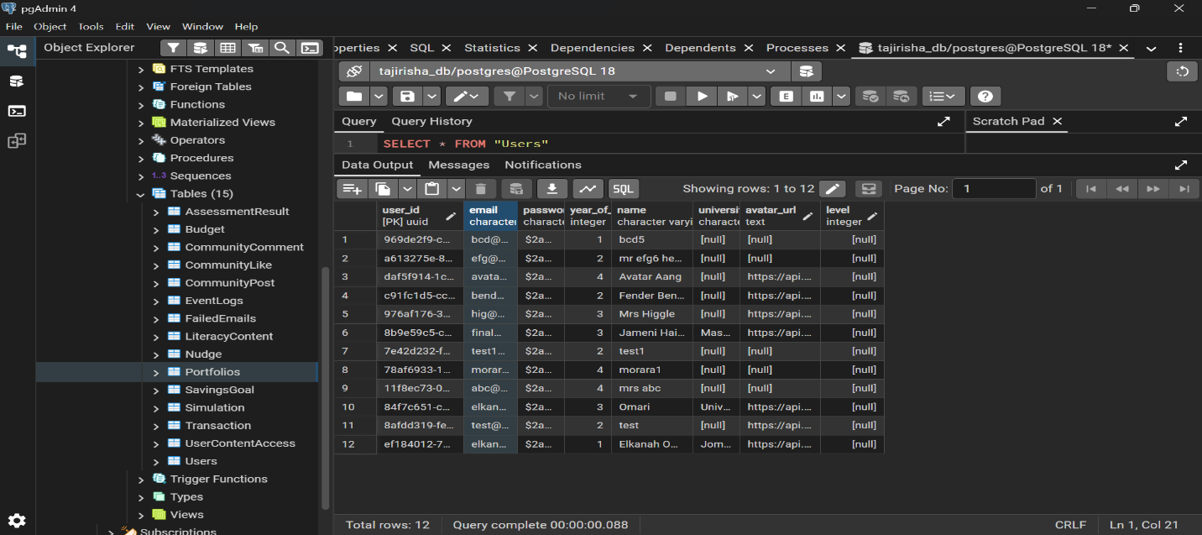
Figure 1: Schema;Populated data Evidence

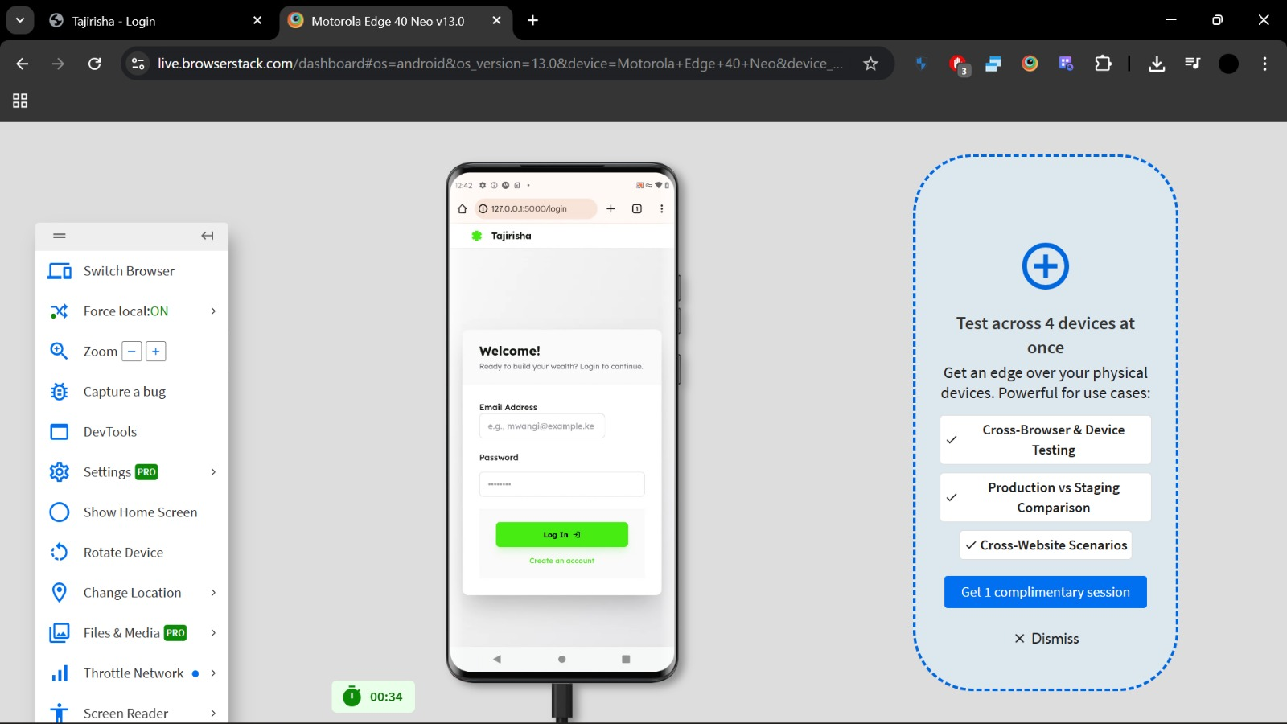
Figure 2: BrowserStack:Chrome on simulated android device
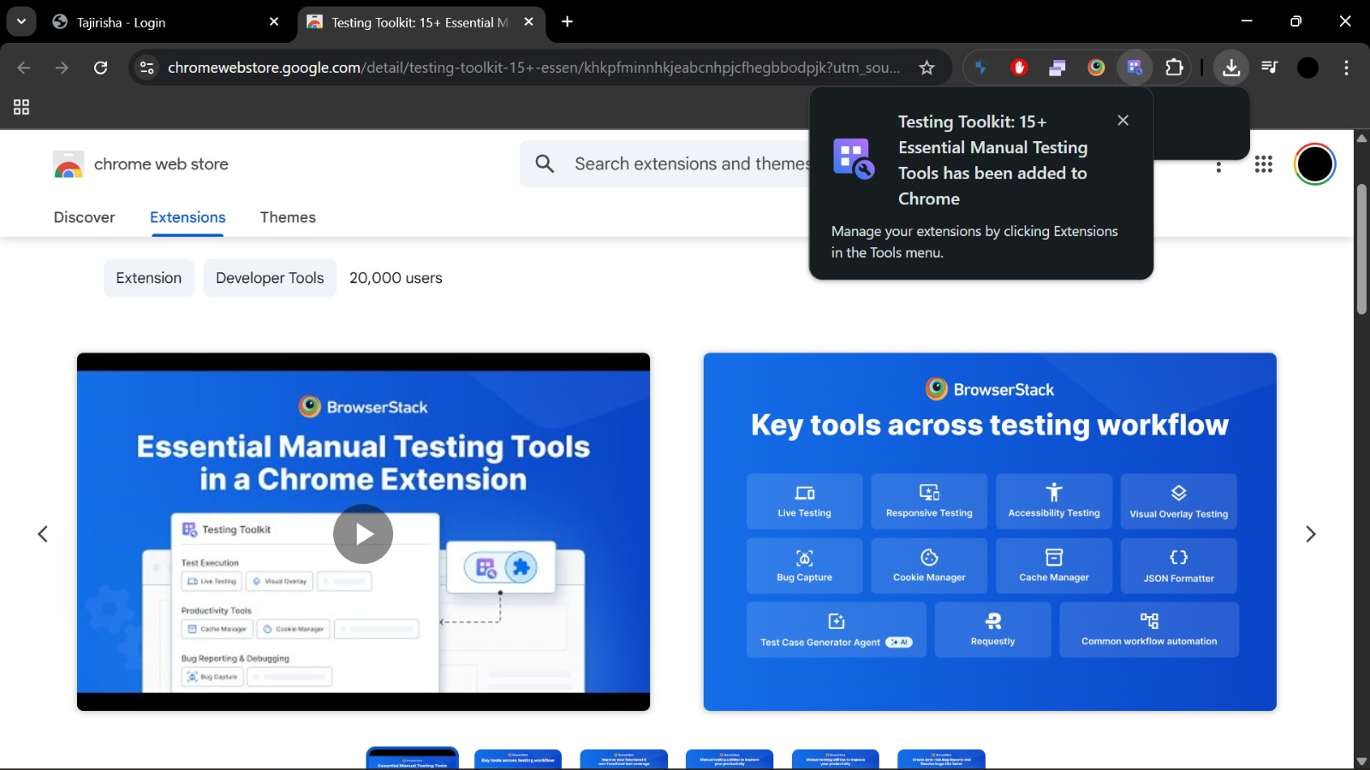
Figure 3:BrowserStack Extension
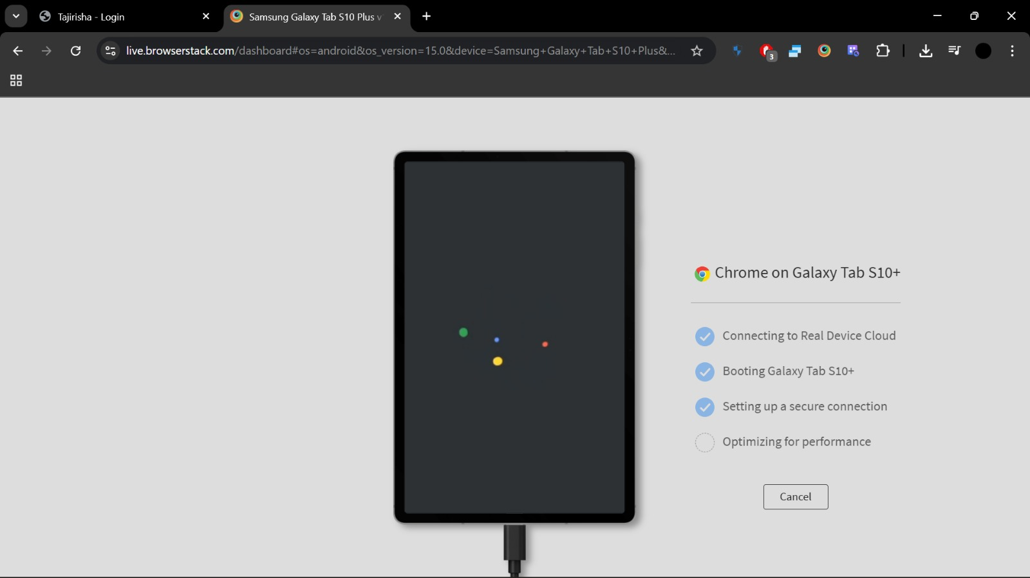
Figure 4: Snippet of how BrowserStack works
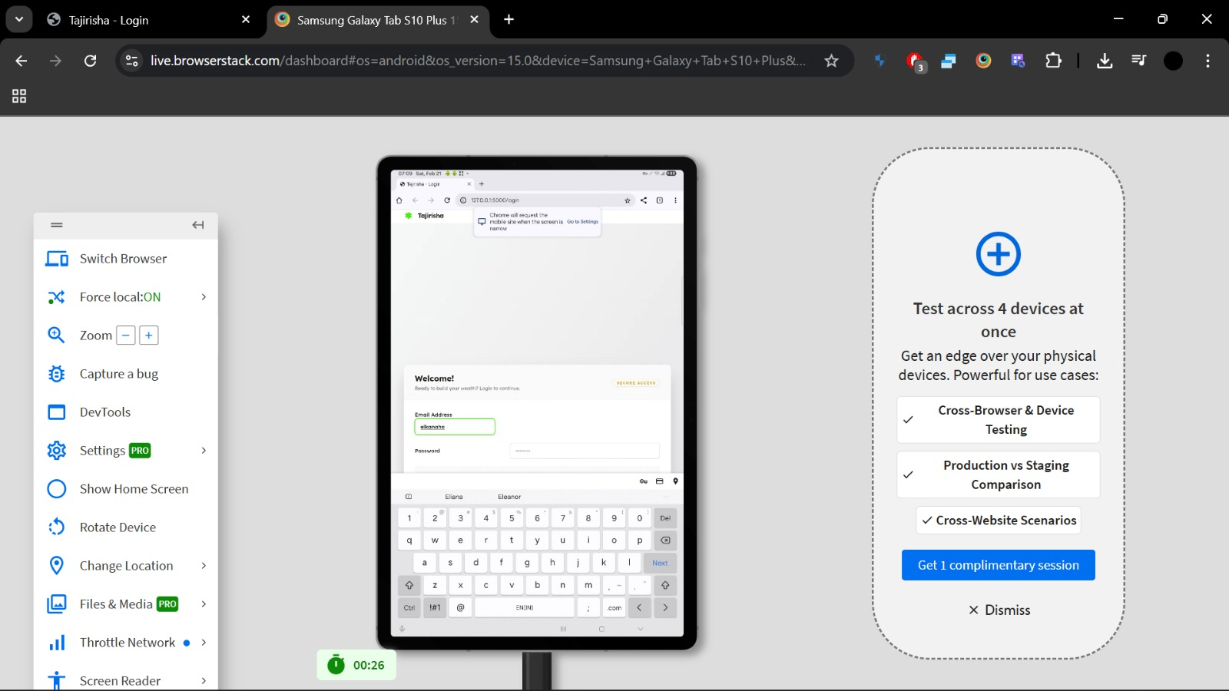
Figure 5: BrowserStack Simulation on Large Devices

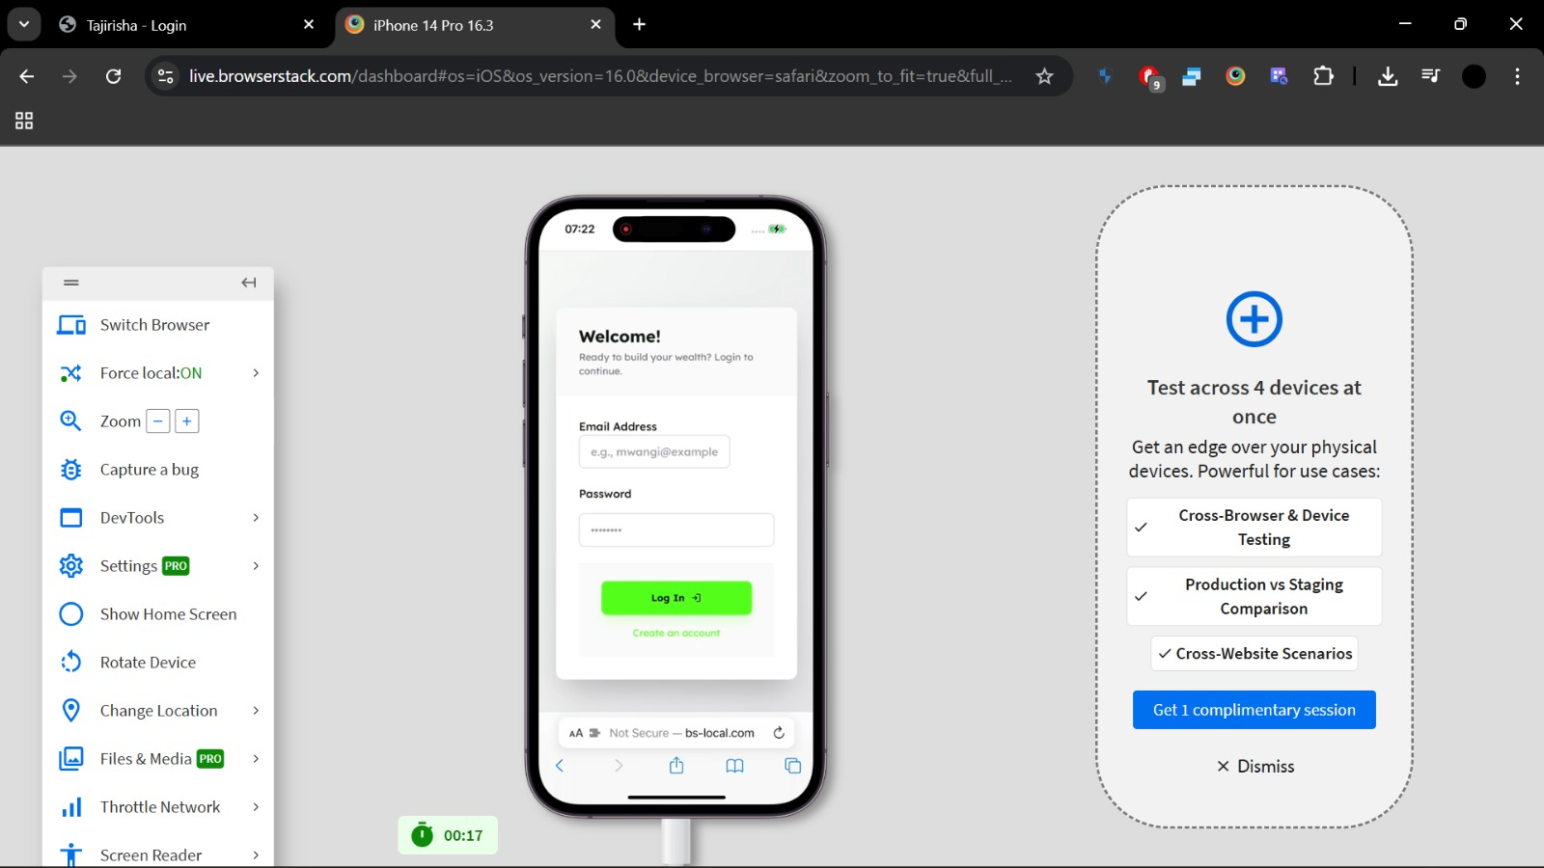
Figure 6:BrowserStack Simulation on Safari Browser
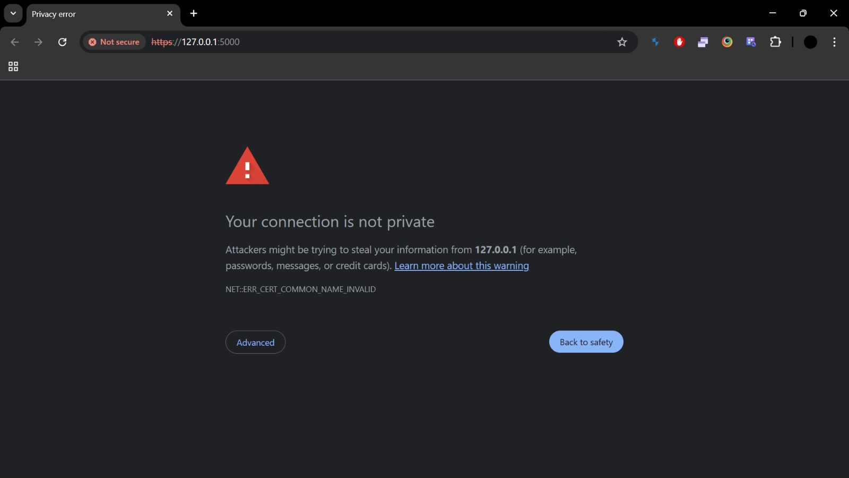
Figure 7: HTTPS Issues when migrating from HTTP
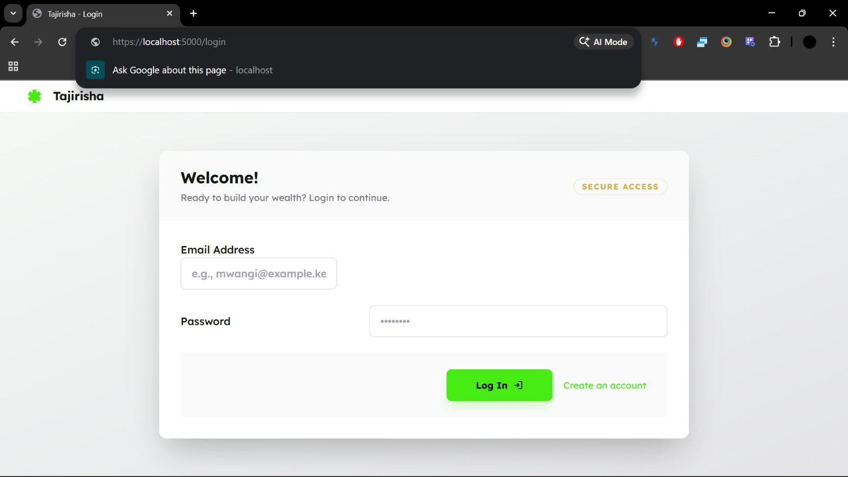
Figure 8: Success after migrating to HTTPS
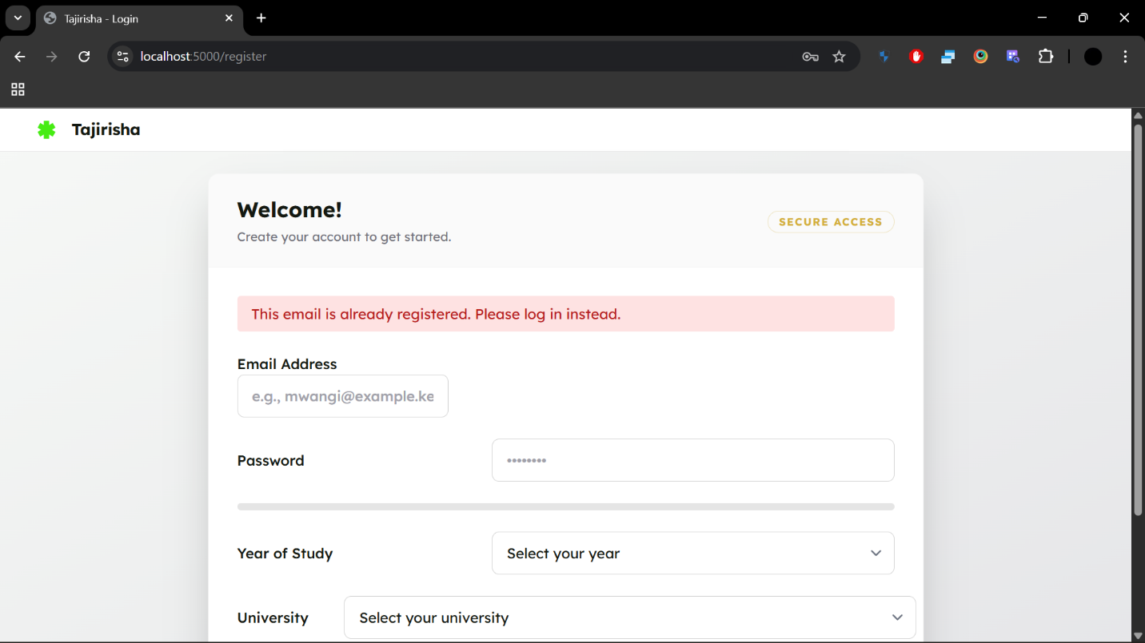
Figure 9:Registration safeguard(UserAlreadyExists)
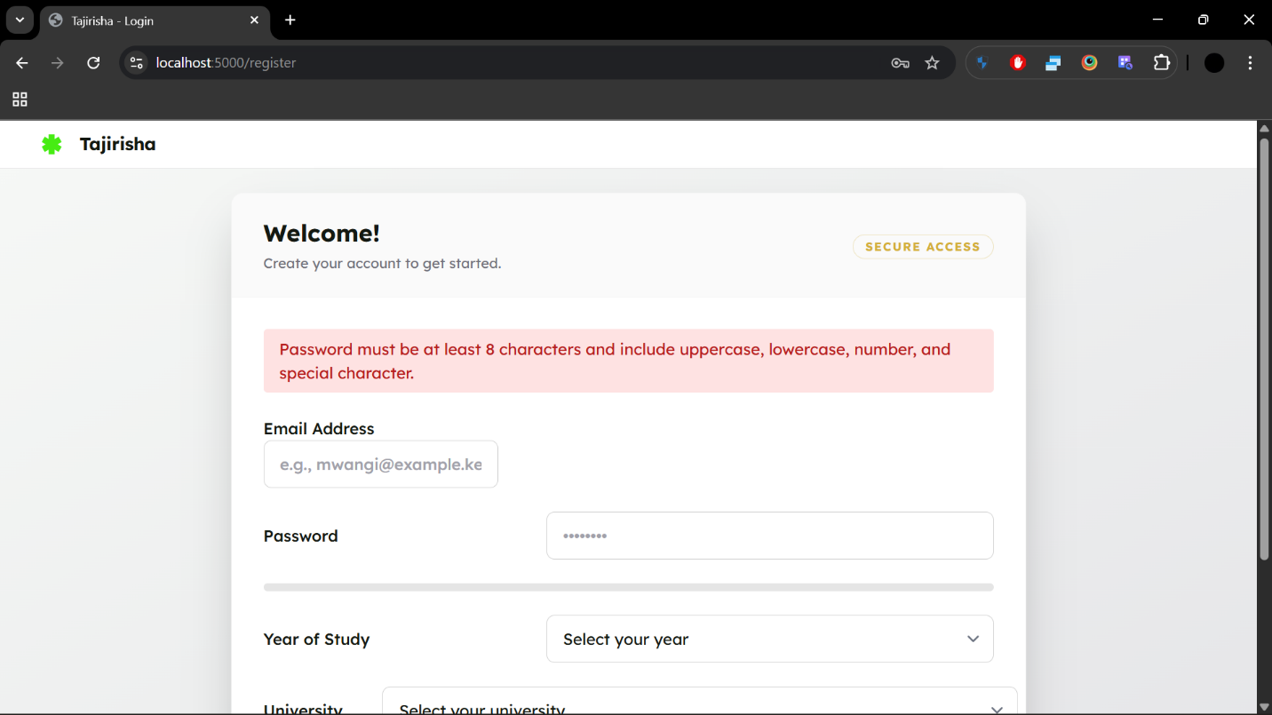
Figure 10: Registration Safeguard(Password requirements)
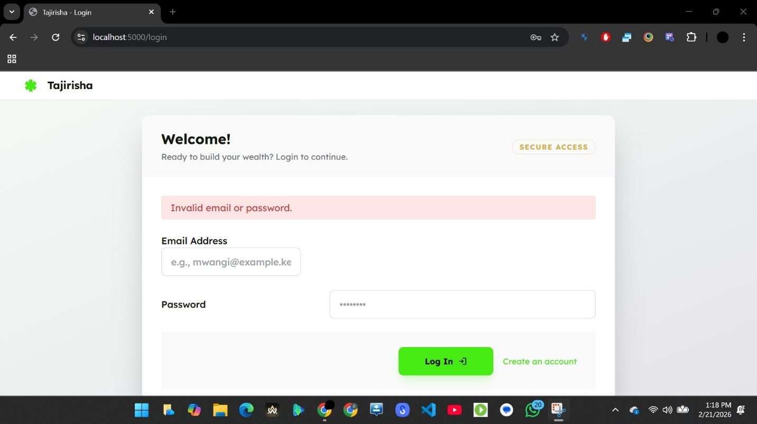
Figure 11: Login safeguards (Invalid email / password)
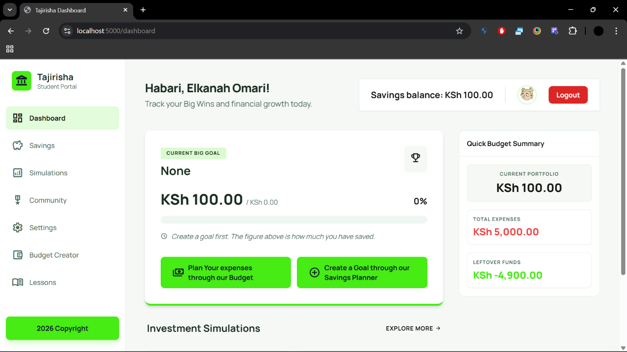
Figure 12: Dashboard

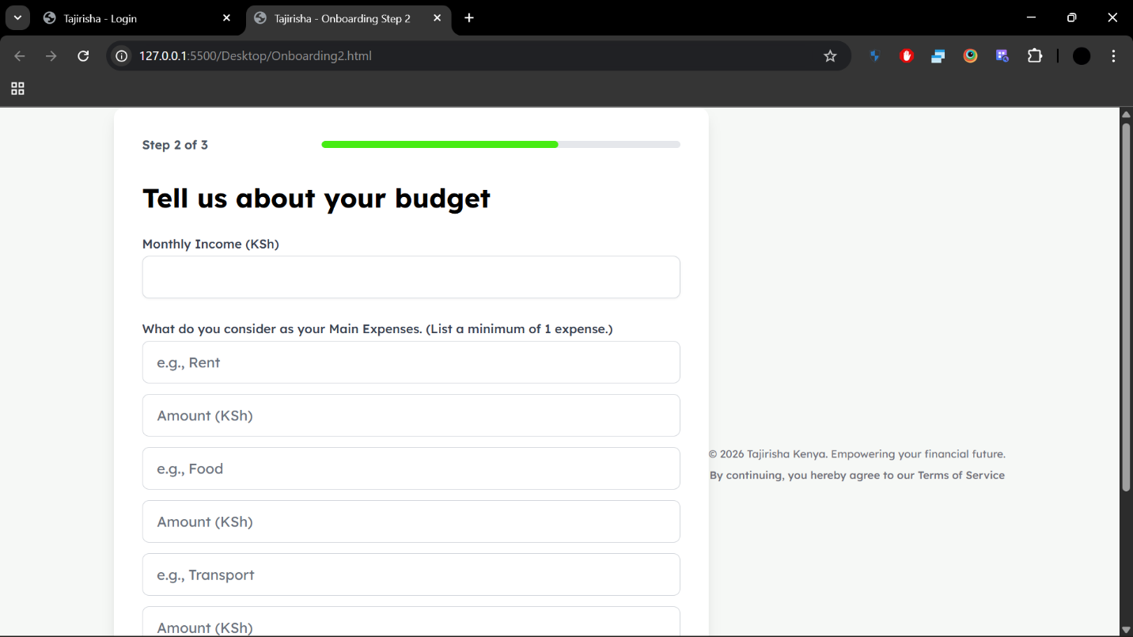
Figure 13: Onboarding2
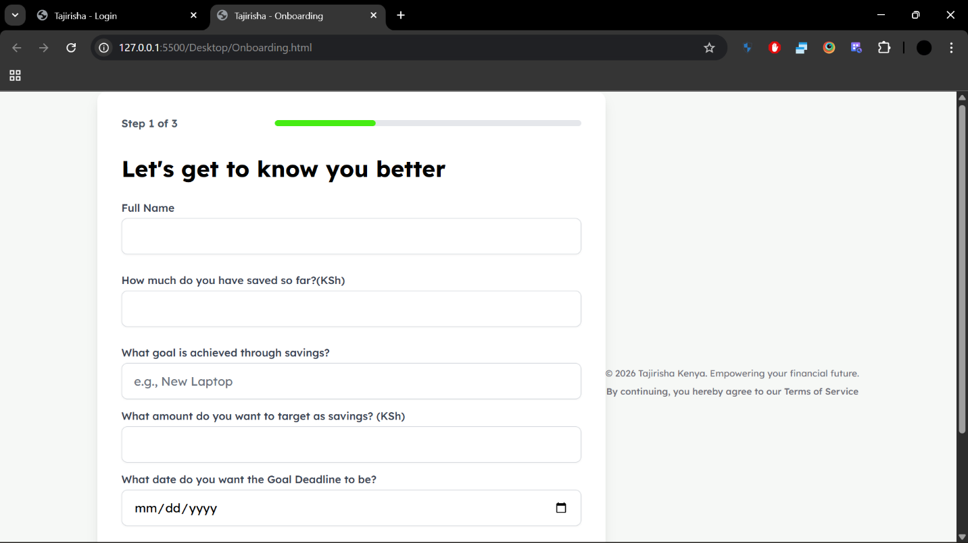
Figure 14: Onboarding 1
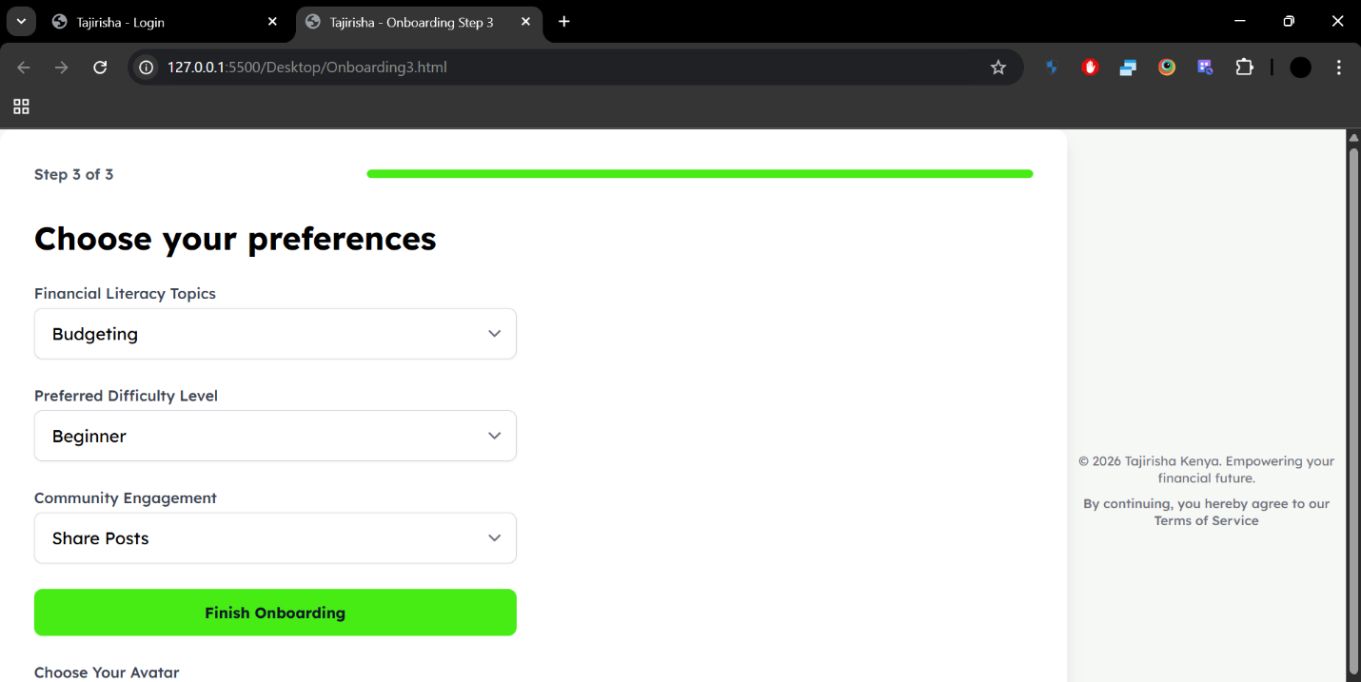

Figure 15:Onbooarding 3
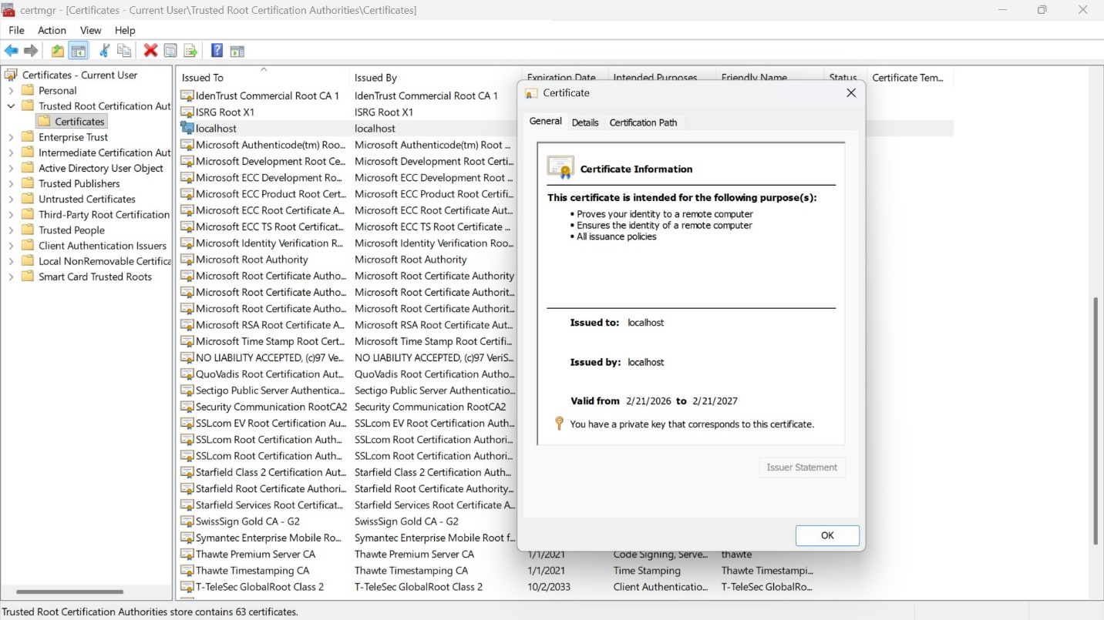
Figure 16: Handling HTTPS certificates

List of Tables
Table 1:Testing Approaches Used 11
Table 2:Test Case Table(Sample) 13
Table 3:Recommendation Matrix 26

List of Figures
Figure 1: Schema;Populated data Evidence 29
Figure 2: BrowserStack:Chrome on simulated android device 30
Figure 3:BrowserStack Extension 30
Figure 4: Snippet of how BrowserStack works 31
Figure 5: BrowserStack Simulation on Large Devices 31
Figure 6:BrowserStack Simulation on Safari Browser 32
Figure 7: HTTPS Issues when migrating from HTTP 32
Figure 8: Success after migrating to HTTPS 33
Figure 9:Registration safeguard(UserAlreadyExists) 33
Figure 10: Registration Safeguard(Password requirements) 34
Figure 11: Login safeguards (Invalid email / password) 34
Figure 12: Dashboard 35
Figure 13: Onboarding2 35
Figure 14: Onboarding 1 36
Figure 15:Onbooarding 3 36
Figure 16: Handling HTTPS certificates 37

Acronyms
- IDE – Integrated Development Environment
- ORM – Object Relational Mapping
- API – Application Programming Interface
- GUI – Graphical User Interface

Definitions of Terms
- Deployment Environment: The hardware and software setup where the system is installed and executed.
- VSCode Terminal: The integrated command line interface within Visual Studio Code used to run and manage applications.
- BrowserStack: A cloud-based testing platform used to validate system compatibility across multiple browsers and devices.
- CRUD Operations: Basic database functions — Create, Read, Update, Delete.
- Middleware: Software layer that manages communication between frontend and backend.
- Cache Control Headers: HTTP directives that define how responses are stored and reused by browsers.

